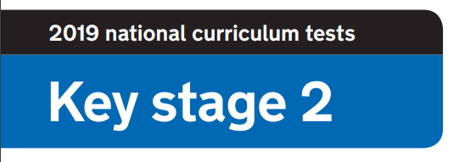
2020 National Curriculum Tests

BBVS Lockdown SATs

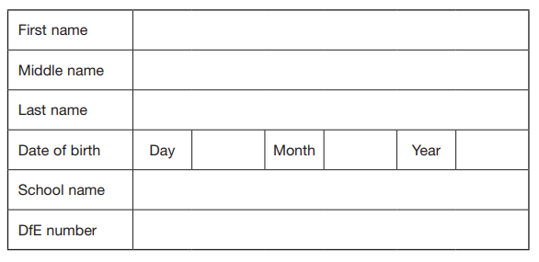



This week should have been your SATs week. A week for you to showcase all the amazing learning you have done in Key Stage Two. Because of lockdown and schools being closed, you are unable to sit your SATs. Instead you can sit your Lockdown SATs at home and have some fun with the silly questions
The purpose of this is for you to enjoy yourself, have a giggle and be proud of your achievements, I know I certainly am!

Please send me your marks and every participant will be awarded a Lockdown SATs certificate.

Paper 1: How well do you know your school?

- What is the school’s vision?
1 mark
- How many posters/pictures are there on the blue wall by Y5?
1 mark
- What are the 4 core values of the school?
4 marks
- What colour is the gorilla by the glass doors?
1 mark
- Name 3 songs we sing in hymn practice.
3 marks
- What is the name of the little yellow and black things on top of the laptop trolley in the main corridor?
1 mark
- How many beanbags are there on the floor in the main corridor? Bonus point: What colour are they?
2 marks
- Name two books on the Y6 ‘Bookflix’ display.
2 marks
- What is the name of the cuddly toy penguin in Y6?
- mark
- How many plants are there in the Y6 classroom?
1 mark

Paper 2: How well do you know chocolate?

Can you name the chocolate bars below?
You will be awarded 1 mark for each correct answer.
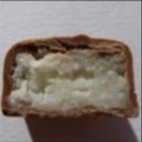 | 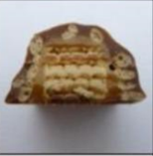 | 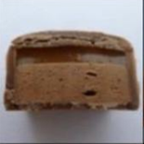 | 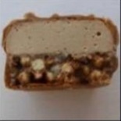
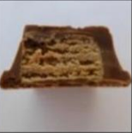 | 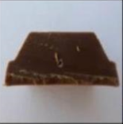 | 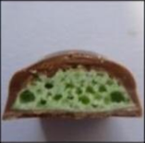 | 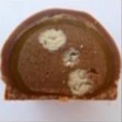
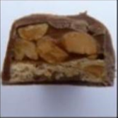 | 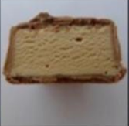 | 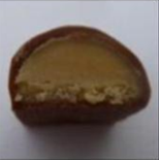 | 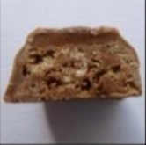
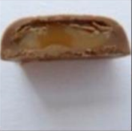 | 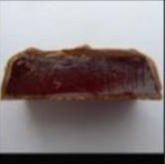 | 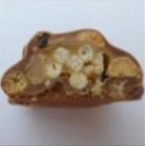 | 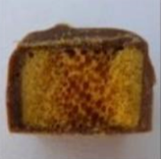

16 marks
Paper 3: Where’s Wally?

Timed paper. You will need a stopwatch.
Time how many seconds it takes to find Wally.
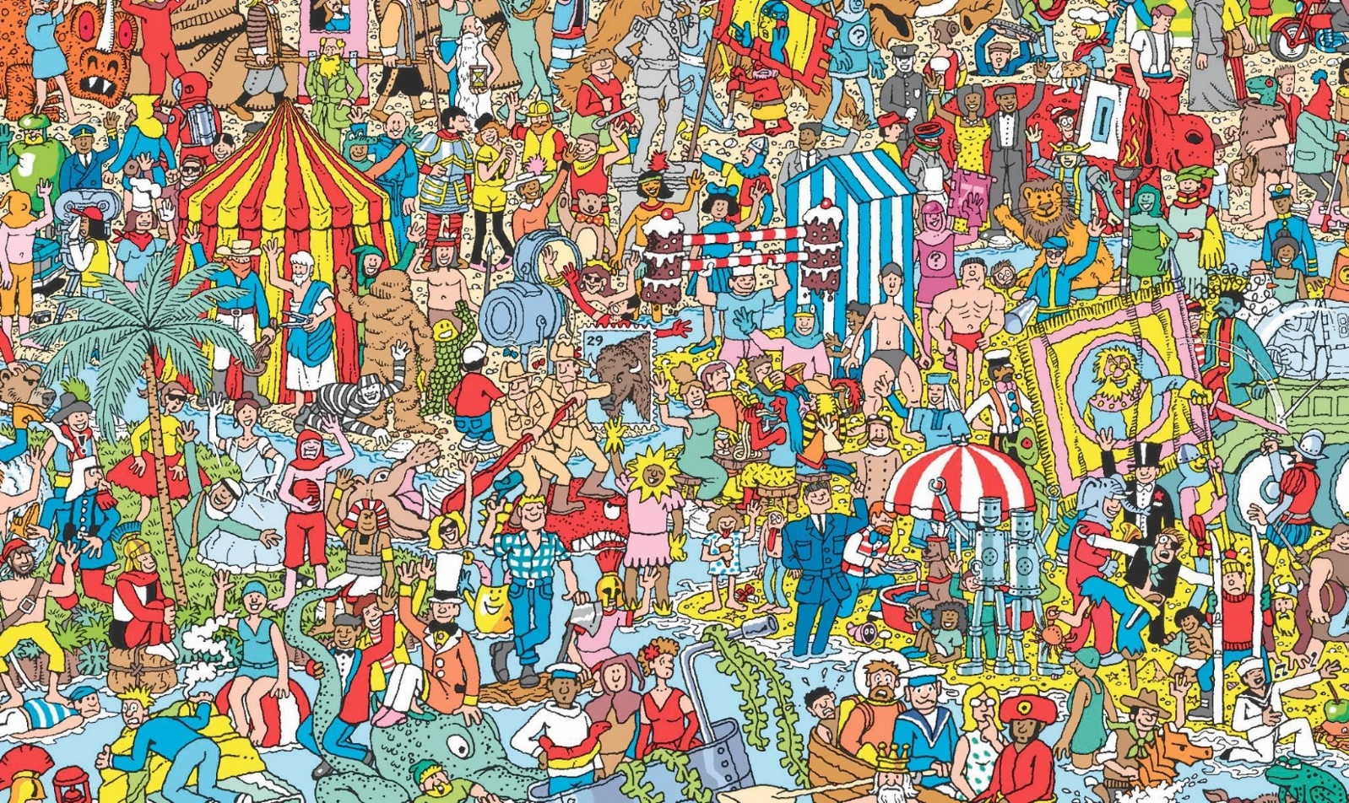

1-30 seconds = 10 marks
31-60 seconds = 8 marks
61-90 seconds = 6 marks
91-120 seconds = 4 marks
121-150 seconds = 2 marks
150 seconds+ = 1 mark

Paper 4: How well do you know the teachers?

Match the boxes to make the sentences true
1 mark for each correct answer
Mrs Nicholas
Miss Reed
was on a CBBC tv programme

has done a parachute jump
Mrs Whiston
has grade 5 in classical guitar
Mrs Boyd
lived in New Zealand for a year

can do the alphabet backwards
Mrs Henshall

met a Man U player on holiday
Miss Davies

did a Segway tour around a Greek island
Mrs Holcombe

was Captain of their college rugby team
Mrs Ball

Paper 5: Scavenger Hunt

Timed paper. You will need a stopwatch.
Starting in the room of your choice, ask a member of your household to time how long it takes to find the objects below. You can find the items in any order. Add a 10 second penalty for any objects not found.

FIND THE FOLLOWING OBJECTS:

- An unused toilet roll

- An item of clothing that is the colour you would get if you mixed blue and yellow together

- An item of clothing that has at least 4 buttons on

- A pen, pencil or crayon that is the top colour of a rainbow

- The word ‘SCHOOL’ - look in a book, magazine or newspaper

- Your postcard from Mrs Ball

- Your school jumper

- A dessert spoon

- A school photograph of yourself

- Something that will hold everything you’ve found

0-5 minutes = 10 marks
5-10 minutes = 8 marks
10-15 minutes = 6 marks
15+ minutes = 4 marks

Paper 6: Spelling Test

You will need a member of your household to read the spelling list in the answer booklet.
- ____________________ 1 mark
- ____________________ 1 mark
- ____________________ 1 mark
- ____________________ 1 mark
- ____________________ 1 mark
- ____________________ 1 mark
- ____________________ 1 mark
- ____________________ 1 mark
- ____________________ 1 mark
- ________________ 1 mark

Paper 7: Art

There
‘Everyday object’ art challenge. Select an object to include in a drawing. Your drawing needs to be assessed by a member of your household and given a score out of 5 for each area: creativity, artistic style and humour!
15 marks
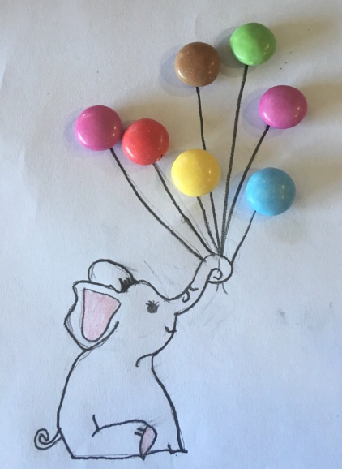
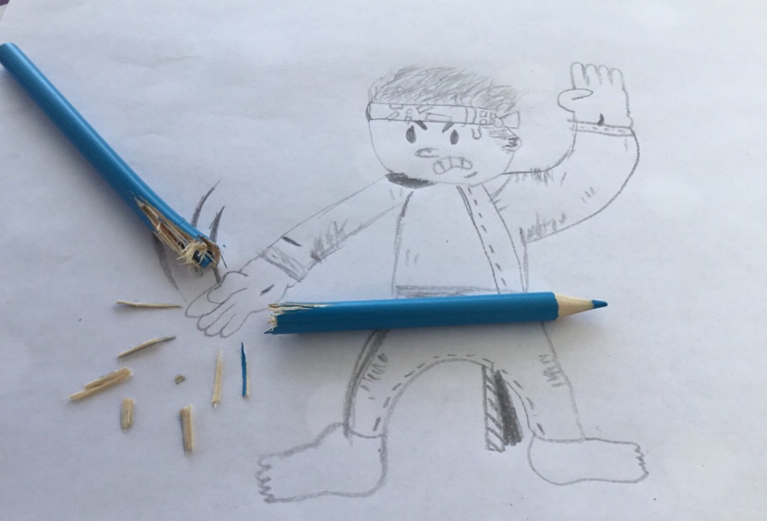
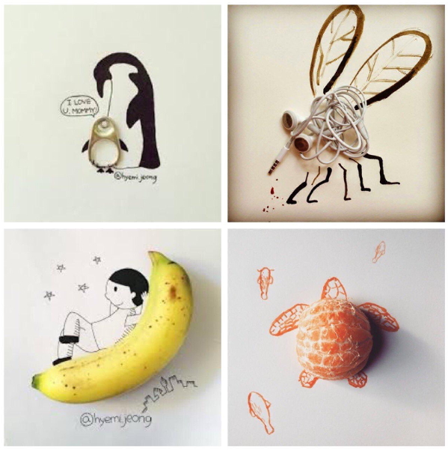
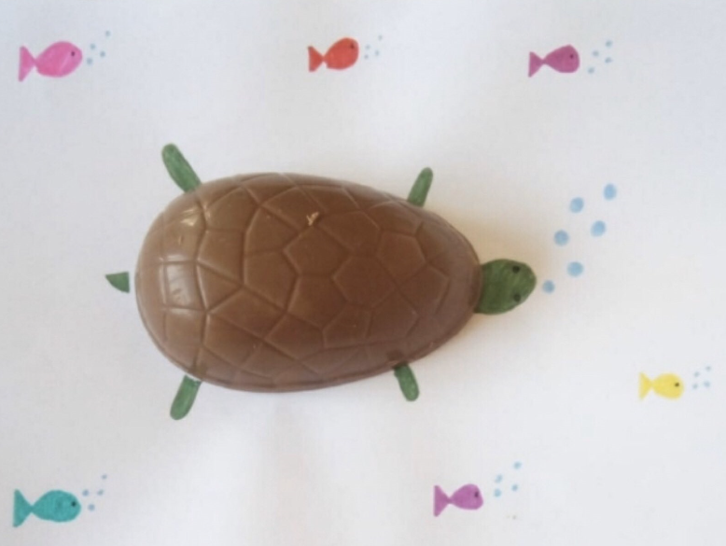
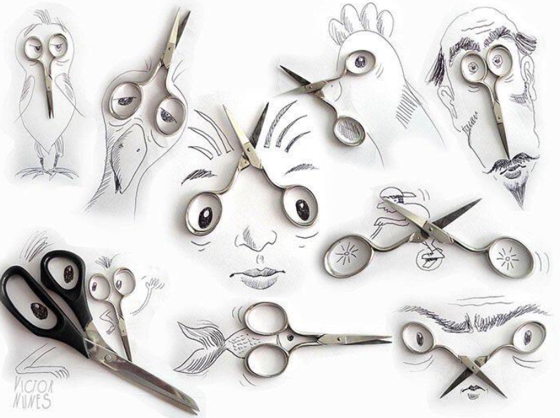

Paper 8: Maths

Solve the maths problems
- Crossing the River
A farmer is trying to cross a river. He is taking with him a rabbit, carrots and a fox and he has a small raft. He can only bring 1 item a time across the river because his raft can only fit either a rabbit, the carrots or the fox. How does he cross the river? (You can assume that nothing is eaten or escapes!)
3 marks
- You are driving a bus to By Brook. You drive through Biddestone and pick 1 child up, you drive through Nettleton and pick 1 child up, you drive through Burton and pick 5 children up, you drive through Chippenham and pick 4 children up. You drive through Yatton Keynell and pick up 10 children. 6 children get off because they decide to walk the rest of the way. Before reaching school, you pick up 14 children from Castle Combe. Who is the bus driver?
1 mark
- How many squares are in the picture?


3 marks

Paper 9: Reading

Name the books using the emoji clue
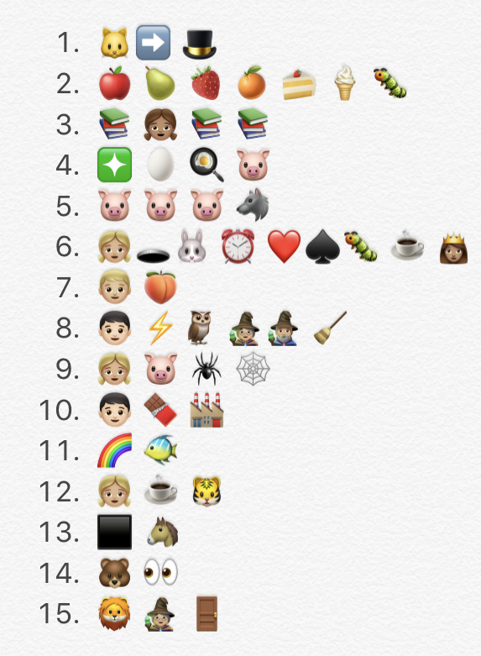
1 mark
1 mark
1 mark
1 mark
1 mark
1 mark
1 mark
1 mark
1 mark
1 mark
1 mark
1 mark
1 mark
1 mark
1 mark

Paper 10: Secondary School

Visit your secondary school’s website and answer the following questions.

- What is your secondary school’s website?
1 mark
- What is the vision or key values? E.g. By Brook Valley – ‘roots to grow, wings to fly.’
1 mark
- What is the principal/ head teacher’s name?
1 mark
- Name 3 teachers.
1 mark
- Name 3 exciting facts.
3 marks
- Draw the school logo.
1 mark
- What is the school uniform?
2 marks
- Do they have a social media page to share information?
1 mark
- Find a quote from a pupil at your secondary school. What do they think of the school?
1 mark
- What sports facilities does your secondary school have?
1 mark
Paper 11: End of SATs celebration

Crazy hair celebration. Your hair style needs to be assessed by a member of your household and given a score out of 5 for each area: creativity, artistic style and humour!
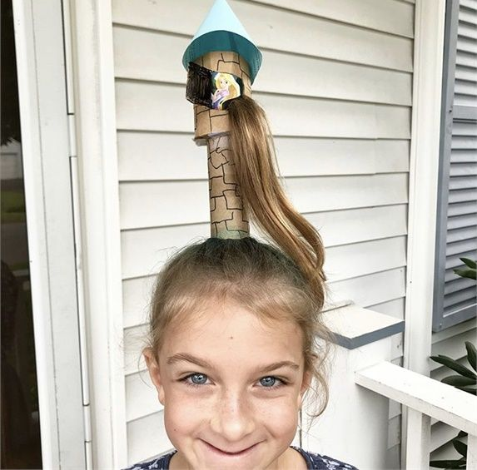
15 marks
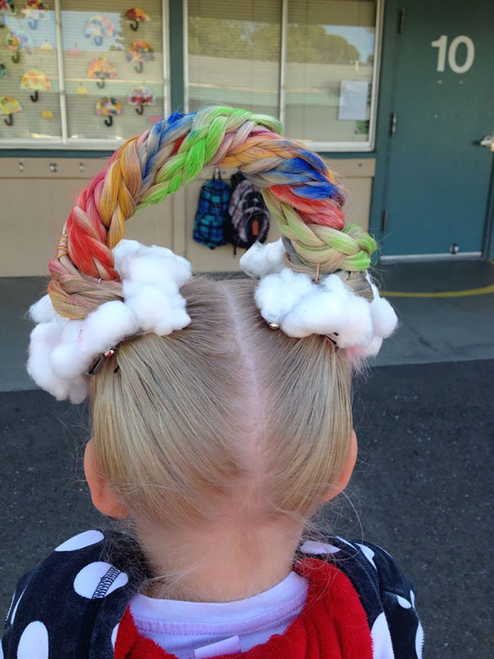
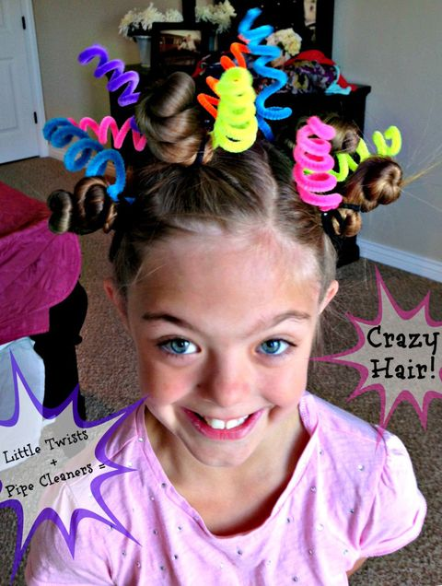

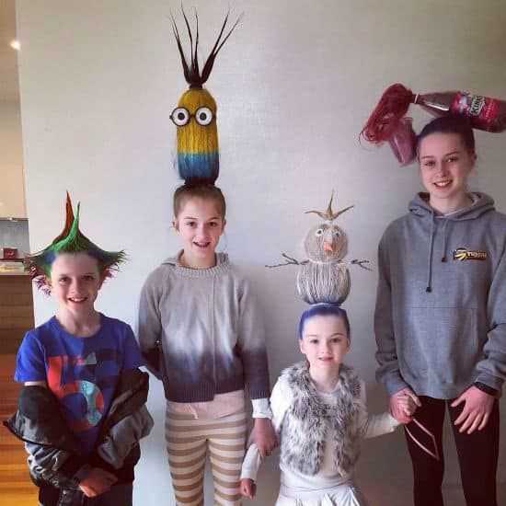
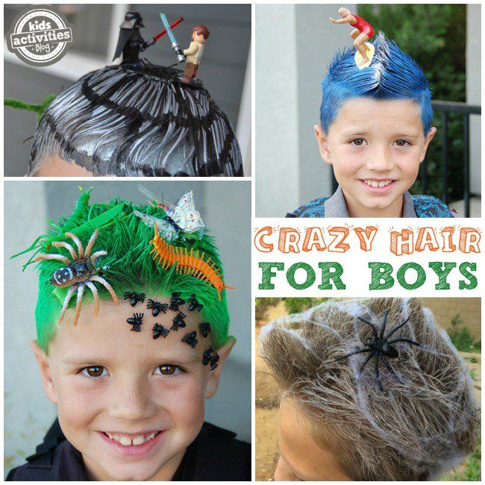

CONGRATULATIONS!

You have completed the Lockdown SATs – CONGRATULATIONS!
Eagles, I am proud of what you have achieved so far in Year 6. Although you have been unable to sit your ‘real’ SATs, that does not take away all the hard work and effort you have put in this year. You are amazing! I have been incredibly lucky to be your teacher for the last two years and I know whatever happens, you will be fantastic at secondary school.
I hope you have enjoyed your silly Lockdown SATs challenges and it has made you smile. I look forward to getting your marks and photos of your art and crazy hair celebration!

Keep smiling and stay positive!

Miss Davies

