Answers
- What is the school’s vision? Root to grow, wings to fly
1 mark
- How many posters/pictures are there on the blue wall by Y5? 4
1 mark
- What are the 4 core values of the school? Hope, honesty, friendship, forgiveness
4 marks
- What colour is the gorilla by the glass doors? Green
1 mark
- Name 3 songs we sing in hymn practice.
3 marks
- What is the name of the little yellow and black things on top of the laptop trolley in the main corridor? Bee Bots
1 mark
- How many beanbags are there on the floor in the main corridor? Bonus point: What colour are they? 3 – dark blue
2 marks
- Name two books on the Y6 ‘Bookflix’ display.
2 marks
- What is the name of the cuddly toy penguin in Y6? Eric
- mark
- How many plants are there in the Y6 classroom? 2
1 mark

Paper 2
- Bounty
- Lion Bar
- Mars
- Double Decker
- Kit kat chunky
- Yorkie
- Mint Aero
- Boost
- Snickers
- Milky Way
- Fudge
- Toffee Crisp
- Cadbury Caramel
- Turkish Delight
- Picnic
- Crunchie
Paper 3
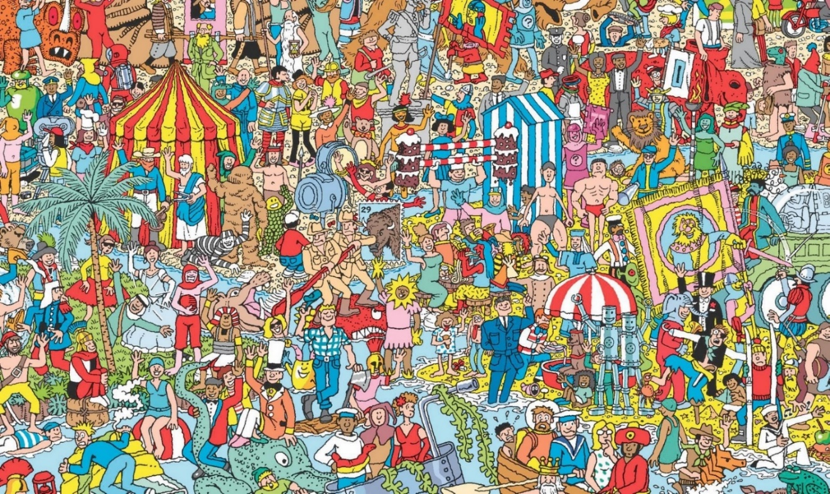

Paper 4
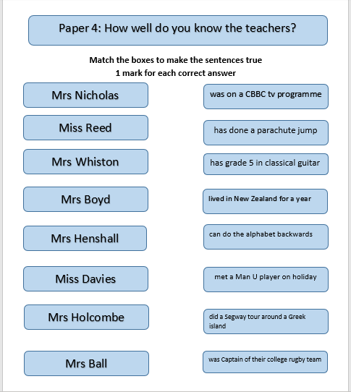
Paper 5
Timed task

Paper 6
- There
- Really
- Is
- No
- Spelling
- Test
- Happy
- Lockdown
- SATs
- Eagles

Paper 7

Art task

Paper 8
- You!
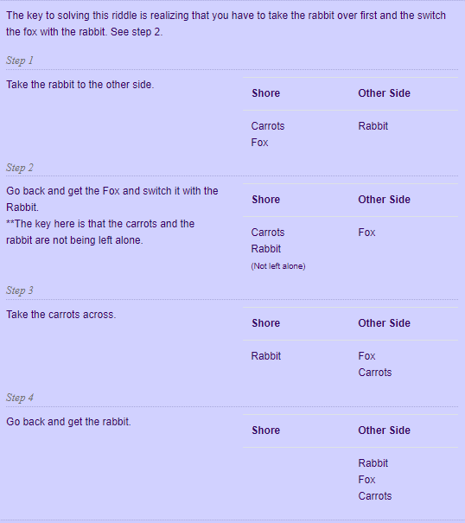

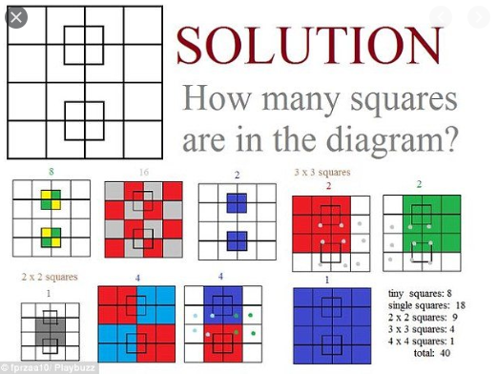

Paper 9
- Cat in the hat
- The Hungry Caterpillar
- Matilda
- Green Eggs and Ham
- 3 Little Pigs
- Alice and Wonderland
- James and the Giant Peach
- Harry Potter
- Charlotte’s Web
- Charlie and the Chocolate Factory
- The Rainbow Fish
- Tiger came to tea
- Black Beauty
- We’re going on a bear hunt
- The lion, the witch and the wardrobe
Paper 10
Secondary schools – different answers

Paper 11
Celebration task

