Why is blood pumped back to the heart?
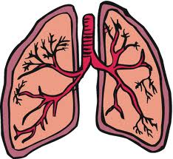
Why does the heart pump blood to the lungs?
Task
- Label the heart.
- Colour the valves in green.
- Colour the left atrium and the left ventricle in red.
- Colour the right atrium and right ventricle in blue

What do the colours red and blue represent?
As the blood travels around the body what does it do?
Where does the blood go when it leaves the left ventricle?
Describe where the blood flows when it enters the right atrium



