- MORE adverbials!
- Use the Revision Card.
- Complete Ananse Adverbials. Underline the main verbs and highlight the adverbials.

2. Now for some writing
- Re-write each of the sentences from Ananse Adverbials with a new adverbial. You could challenge yourself to write two new versions for each sentence.

Revision Card – Adverbials

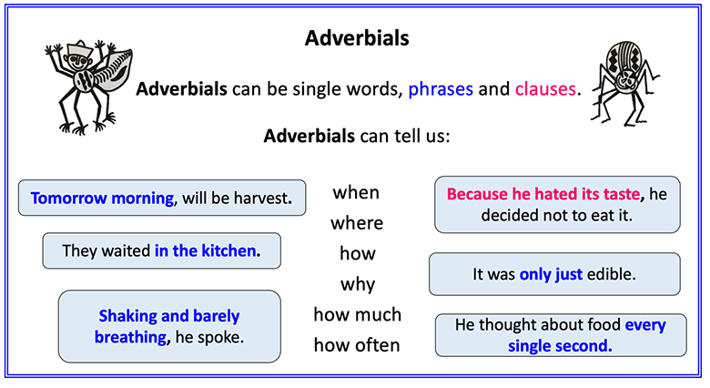
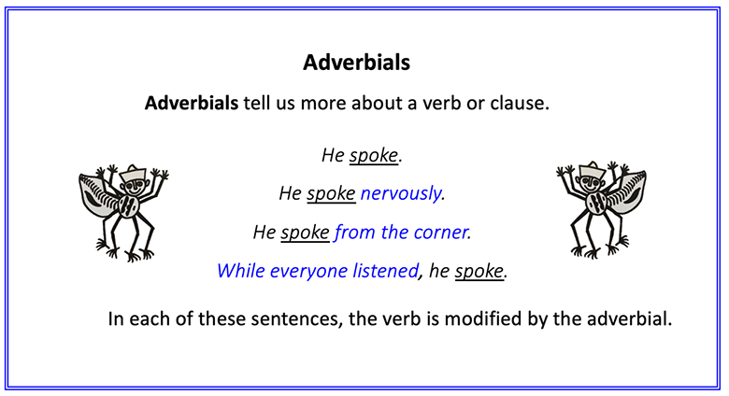
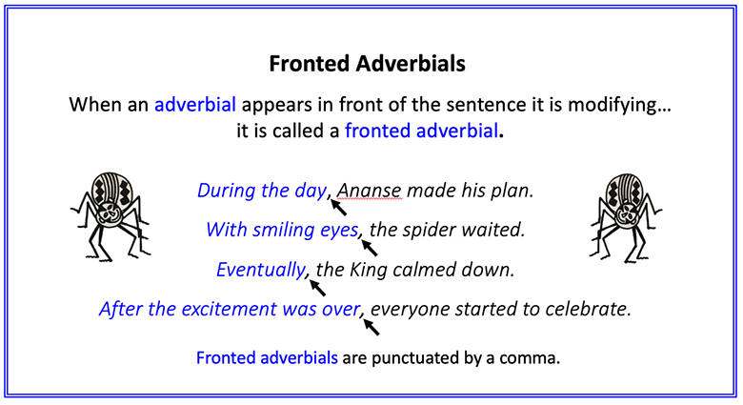

Ananse Adverbials

Underline the main verb and highlight the adverbial. Write whether it is answering WHEN, WHERE or HOW.

1. Ananse had journeyed through the forest lands.

2. After several days of tracking through the forest, his journey was completed.

3. On the nights spent in the forest, he had dreamed of food.

4. At last, he was in the great town of Po-Ano.

5. In the palace, Ananse could smell delicious food.

6. Ananse dressed excitedly.

7. With a flourish, the king’s wife lifted the lid.

8. Ananse collapsed in shock.

9. In the forest lands, this was called Face-the-Wall.

10. Thinking quickly, Ananse made a plan.
Ananse Adverbials - ANSWERS

1. Ananse had journeyed through the forest lands. (WHERE)
2. After several days of tracking through the forest, his journey was completed. (WHEN)
3. On the nights spent in the forest, he had dreamed of food. (WHEN)
4. At last, he was in the great town of Po-Ano. (WHEN)
5. In the palace, Ananse could smell delicious food. (WHERE)
6. Ananse dressed excitedly. (HOW)
7. With a flourish, the king’s wife lifted the lid. (HOW)
8. Ananse collapsed in shock. (HOW)
9. In the forest lands, this was called Face-the-Wall. (WHERE)
10. Thinking quickly, Ananse made a plan. (HOW)
New Sentences
Re-write the Ananse Adverbial sentences with new adverbials. The Adverbials Bank could help you with ideas.


Adverbial Bank

Adverbials often start with prepositions or conjunctions

Prepositions |  |  | Conjunctions
When? | Where? | How? | Where? | When? | Why?
before  after  while  in  on  at  during | above  below  inside  outside  to  on  from  under | in  with  as  like | where  wherever | after  before  when  since  until  as  while | because  as  so  since

