1. Plan a story
- Look at Ananse Illustration. Imagine what might be happening here.
- Answer the Story Prompt Questions using your imagination.
- Now plan out a story based on your ideas. Use words and pictures on Story Planner to show how you will tell your story.

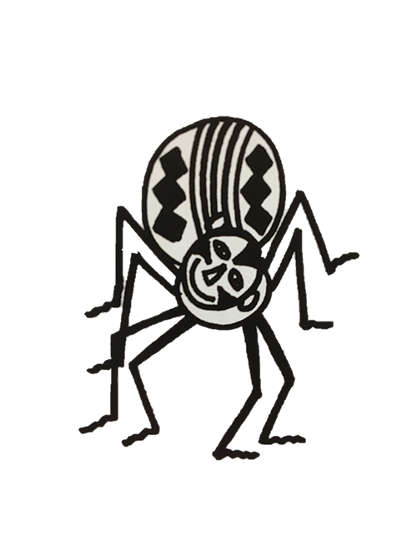

Ananse Illustration

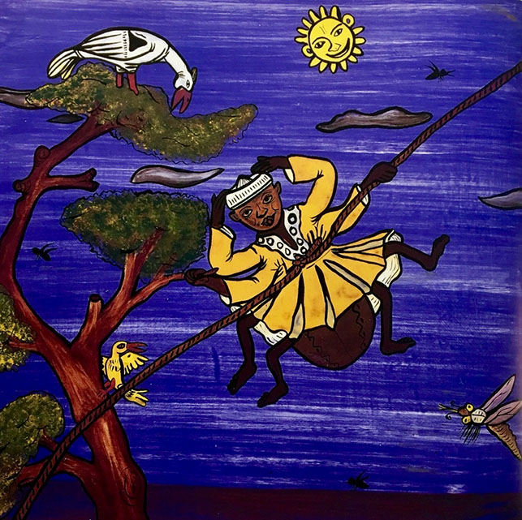

From The Pot of Wisdom by Adwoa Badoe and Baba Wague Diakite

Story Prompt Questions

Why do you think that Ananse is up in the air?

What might he be saying?

What might the bird be thinking?

What do you imagine happened to Ananse just before this picture?

What might happen to him next?
Story Planner
1 | 2 | 3
4 | 5 | 6

Adverbial Bank

Adverbials often start with prepositions or conjunctions

Prepositions |  |  | Conjunctions
When? | Where? | How? | Where? | When? | Why?
before  after  while  in  on  at  during | above  below  inside  outside  to  on  from  under | in  with  as  like | where  wherever | after  before  when  since  until  as  while | because  as  so  since

