Owls ‘Amazing Me’ Knowledge Organiser – Autumn Term 1 2023
- Our key question for this topic is: Why am I amazing?
Key Vocabulary
Amazing | Brilliant, wonderful, very good.
The Same | Matching, alike, identical.
Different | Not the same, unalike.
School | The place we go to learn and grow.
Rules | Important guidelines of how we should behave.
Promises | Agreeing to be ready, respectful and responsible.
Values | Ideas we believe are important.
Season | A section of the year, known for weather and daylight hours.
Autumn | The season after Summer, before Winter, running from September to November.
Harvest | The collection of crops.
- Key areas of learning: Personal, Social, Emotional Development (PSED), Communication and Language (CL) and Understanding the World (UW).
- By the end of this topic I will know: What makes me special and amazing, how I am the same and different to others, how to write my name, how to follow the school rules, promises and values, what season we are in, why we celebrate Harvest, and how to count to 10.
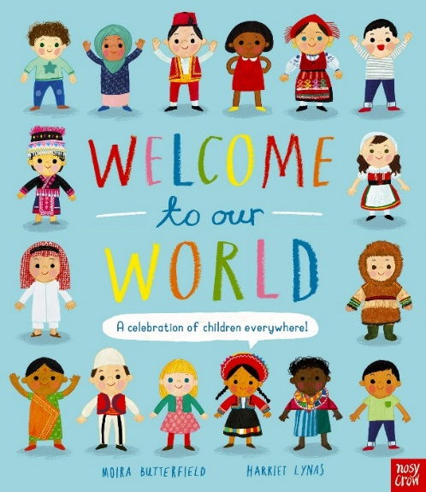
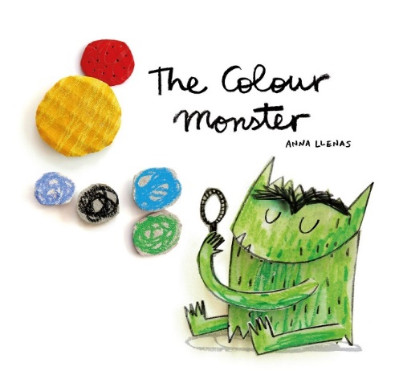
- The books we will be reading this term are: The Colour Monster, Welcome to Our World, Owl Babies, Leaf Man, Stick Man, Oi Frog and Be More Bernard.
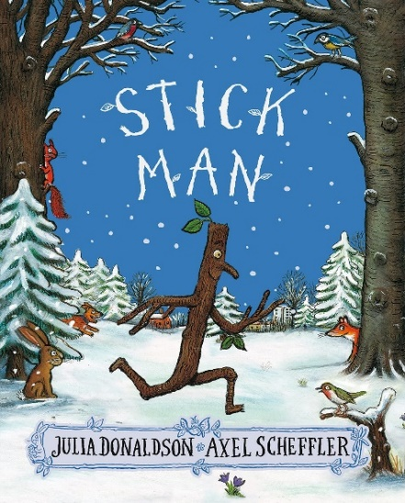
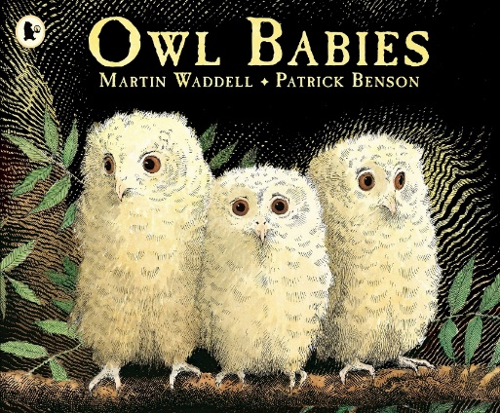

ROOTS TO GROW, WINGS TO FLY

"They will soar on wings like eagles."

