Owls ‘Celebrations’ Knowledge Organiser – Autumn Term 2 2023

- Our key question for this topic is: How do people celebrate?
- Key areas of learning: Personal, Social, Emotional Development (PSED), Communication and Language (CL) and Understanding the World (UW).
- By the end of this topic, I will know: What Diwali, Hanukkah and Christmas are and who celebrates them, the Nativity story, what happens on bonfire night, how to follow/order instructions and how to write a list. I will also be more confident in my reading of simple sentences, writing CVC words and my knowledge of numbers to 10. I will be able to continue an ABAB repeating pattern and identify common 2D shapes.
Key Vocabulary
Instructions | The steps needed to complete a task, followed or given in a specific order.
List | Short pieces of information, such as names, with one piece of information on each line.
Christmas | The date when Christians celebrate the birth of Jesus.
Nativity Play | A play or performance based on the story of the birth of Jesus.
Celebration | The act of celebrating an important date or event.
Hanukkah | Also known as the Festival of Lights, a Jewish 8-night celebration.
Diwali | The Hindu Festival of Light which lasts 5 days during October/November.
Religion | A set of beliefs.
Repeating | A recurring pattern
2D | A two-dimensional object, something ‘flat’.
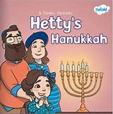
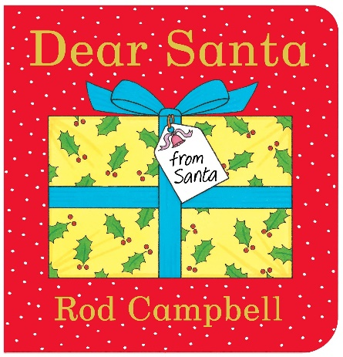
- The books we shall read during this topic are Bonfire night poems, Dipal’s Diwali, Hetty’s Hanukkah, Dear Santa, The Jolly Postman’s Christmas and a series of non-fiction texts.
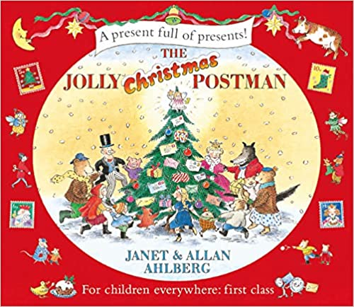
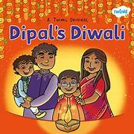

ROOTS TO GROW, WINGS TO FLY

"They will soar on wings like eagles."

