How does the weather impact Florida?
Roots to grow, wings to fly
Growing, Flourishing, Soaring.

English
We will focus on non-fiction writing this term. We will write a non-chronological report about Florida and write a narrative based of a short clip called The Lighthouse
In grammar, we will be learning about complex sentences, re-visiting present tense, technical vocabulary, power of three and show not tell.
Maths
We will start this term off with an introduction to Area, before moving back to multiplication and division, where we will be revisiting multiplying 2 digit numbers by a 1 digit number, before moving on to multiplying a 3 digit number with a 1 digit number, later in the term we will be visiting fractions and introducing decimals for the first time.
Geography
We will be looking at how the weather impacts Florida. We will be building on our geographical knowledge, the position of Florida in the world, the climate of Florida and how this impacts the weather.
We will be starting with a geographical knowledge revisit before moving onto learning about Florida!
Science
Our focus this term is animals and humans up until half term and Living things and habitats after half term. We will be learning about the digestive system, the importance of our teeth and food chains within the animal kingdom. Our living things and habitats topic will be looking at classification of living things and the importance of the environment.
RE
We will be focusing on Judaism, and how important is it for Jews to do what God asks. Our Christianity topic will be exploring is forgiveness always possible for Christians?
Computing
As part of our online safety topic, we will be exploring privacy and security when creating, communicating and sharing online. We will also beginning to look at basic programming studying repetition and shapes.

Art and DT
We will look at different painting techniques and use the environment as our inspiration to create our own landscapes. Our DT unit later this term will be cooking and where food comes from.
French
We will be recapping and building on learning from year 3, building on our learning numbers, introducing nouns and adjectives in French.

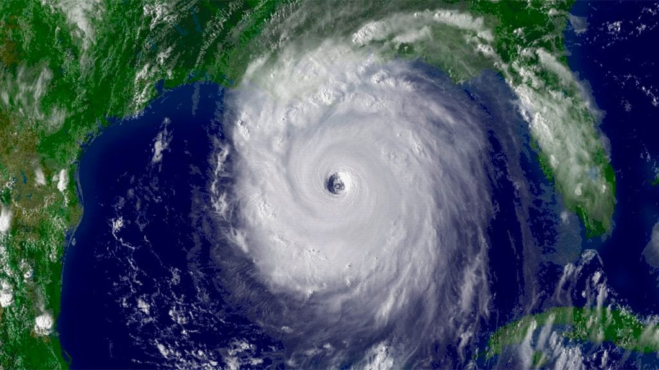
Class information:
PE will be on a Wednesday and Friday.
We will try to be out on Wednesday as much as possible, please provide spare uniform and shoes in case it is muddy.
Please remember swimming kits for Friday.
Reading Records will be checked on Fridays, please remember to sign these.
Hawks Spring 2026
PE
Wednesday: PE with our Sports Coach will be Tag Rugby. Friday: We will be swimming, please ensure children have their swimming kits with them.
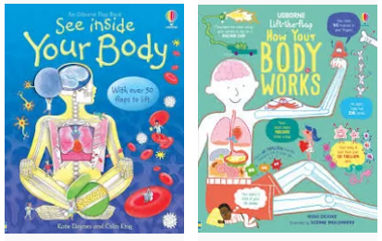
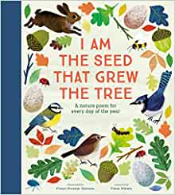
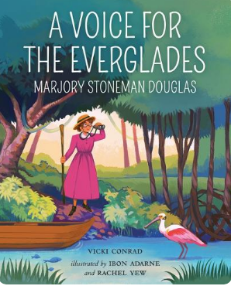
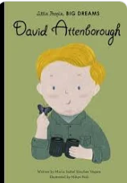
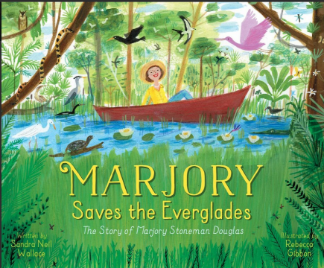
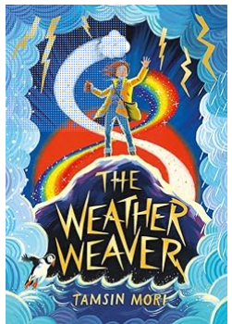
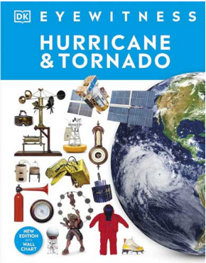
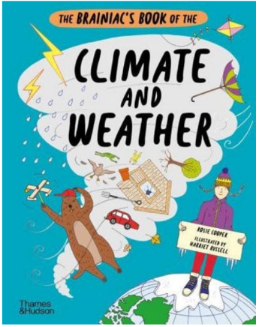
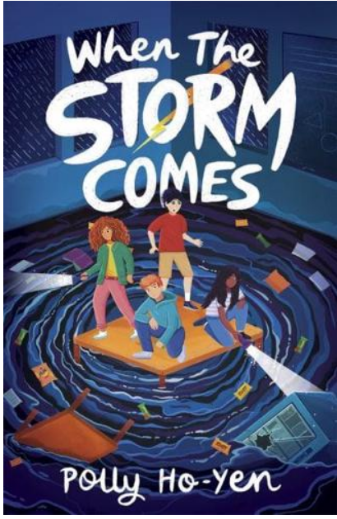
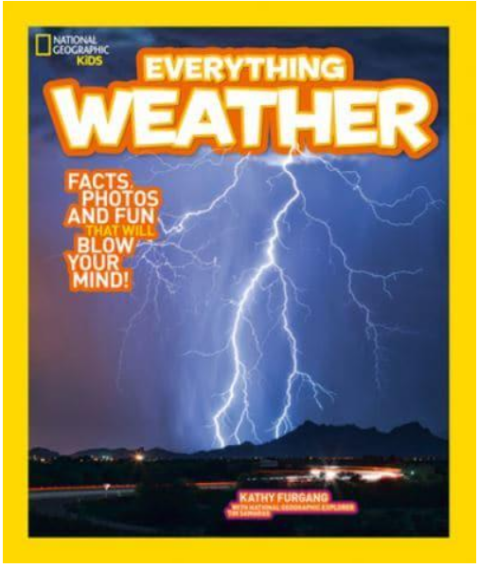
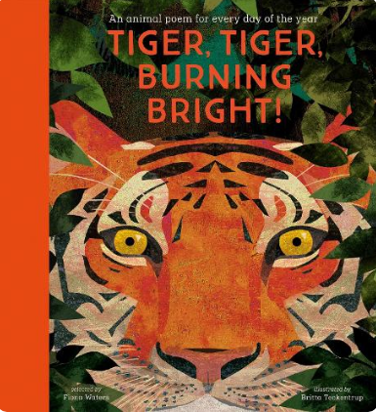
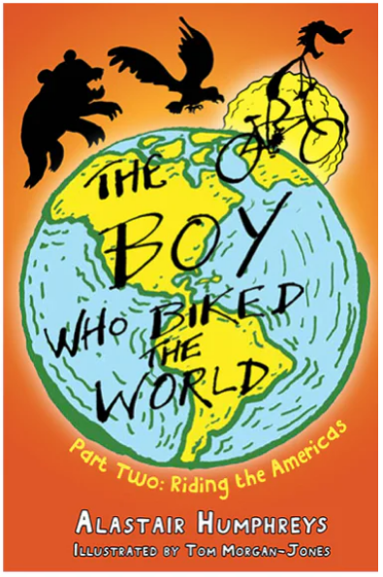
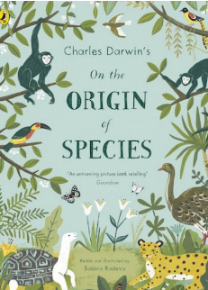
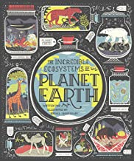
The Boy Who Biked Around the World: Part Two: Riding the Americas will be our class read.
Recommended Reading List for Y4:

