Links for week 4 https://educationendowmentfoundation.org.uk/public/files/videos/EEF_Supporting_daily_routines_during_school_closures.mp4

Daily lessons : www.bbc.co.uk/bitsize
Nearly created maths and English lessons for each year group (Y1) each day as well as another curriculum topic
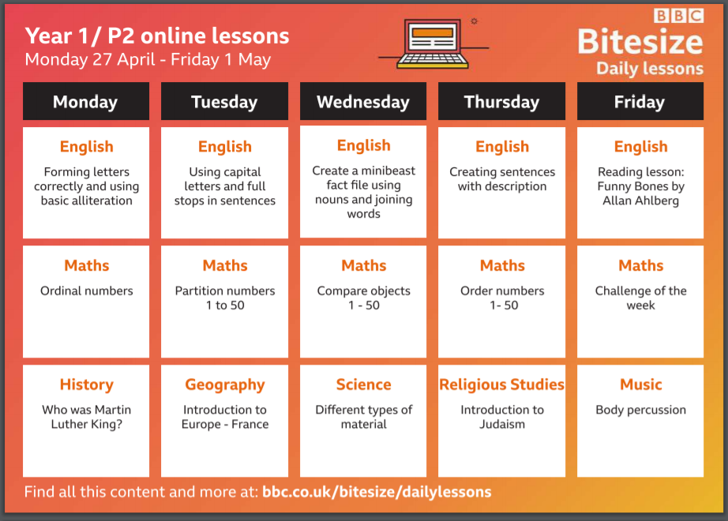
BBC Daily is also available on iplayer- on any device and on TV via the red button. These are 20min programmes target to a specific age group (KS1) https://www.bbc.co.uk/bitesize/articles/z6vpnrd
Maths additional support
White Rose Mathematics home Learning www.whiterosemaths.com/homelearning
You will find here 5 prepared lessons for each day for each year group. They include a short video showing you and your child how to complete the daily activity. Worksheet do need to be printed though.
NCETM is also offering short video interactive daily lessons for KS1 www.ncetm.org.uk/resources/5545
Phonics additional support
Letters and sounds online lessons provided by the Department for Education, available from 27th April from Letters and Sounds for home and school, these are lesson written and presented by phonic experts. A short introduction and link can be found here
https://www.youtube.com/watch?v=UnM6XDFNCFE

Phonics play all games are currently free https://new.phonicsplay.co.uk/

