1. Read the end of the story.
- Read Ananse, the forgetful guest – Part 2. This is the end of the story we began on Day 1. How does this ending compare with the ending that you predicted?

2. CPG Book Pages 18-21

Ananse, the forgetful guest – Part 2

This is the end of the story about Ananse - the half-spider/half-man character.
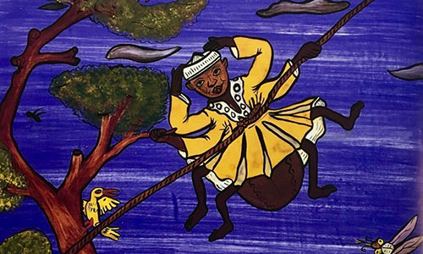

The last day of Ananse's visit fell on the harvest celebrations. A great feast was anticipated. By now Ananse wished strongly that he could be allowed just a small bite of cassava, which the people of Po-Ano cooked in so many delightful ways. There were spicy cassava fries, cassava and vegetable stir-fry, not to mention the soups and stews with which cassava was served.

That night, he hatched a plan. The next day dawned bright. Everywhere, people bustled about preparing food and preparing themselves for the feast in the public square where the king would be in attendance. Early that afternoon the people of Po-Ano gathered and the king made his entrance. But Ananse was nowhere to be found.

Then in the lull before the dancing started, a very odd figure in the rough clothes of a farm labourer appeared.

"Ananse!" the king thundered. "What is the meaning of this...this insult! Why aren’t you wearing proper clothes?"

"I beg your pardon, sir, but I thought we were going harvesting today," said Ananse.

"No!" shouted the crowd. "Today is the harvest celebration!"

"Oh, no," said Ananse, hanging his head in apparent shame. "You must think I'm crazy but really I'm not. It is just this awful forgetfulness that comes over me occasionally. It is the same forgetfulness that made me say cassava was forbidden to me when actually it is one of my favourite vegetables!"

The king was pleased to forgive him and pleased that he did eat cassava. The people of Po-Ano were pleased to share their feast with him. Many secretly thought that Ananse was kind of strange, but since his visit people sometimes plead his kind of forgetfulness whenever they are caught in a sticky situation.

