Online resources …

Type the names in bold into the Youtube search bar for a variety of activities.

* **Joe Wicks HIIT for kids** (high intensity interval training for children. Great ways to burn energy in a short 10 minute session).
* **Just Dance for Kids** (dance videos for children to join along with).
* **Cosmic Kids Yoga** (yoga session videos for children to follow).
* **Moovlee** (calming/meditiation stretching for children. Follow along to the ‘calming monkey’ on the screen and enjoy!).

No equipment needed …

* **Skipping contest** (even if you don’t have a skipping rope. Challenge your family to an invisible skipping contest! Who can last the longest?).
* **Musical statues** (ask your family to join in a game of musical statues, the winner can be the judge next time around).
* **Dance routines** (choose your favourite song and create a dance routine to show your family).
* **Nature walks** (if possible, go out for a long nature walk. See what you can see, hear and feel).

PE Activities

Ideas on how to keep fit at home ☺

*By Brook Valley C of E Primary*

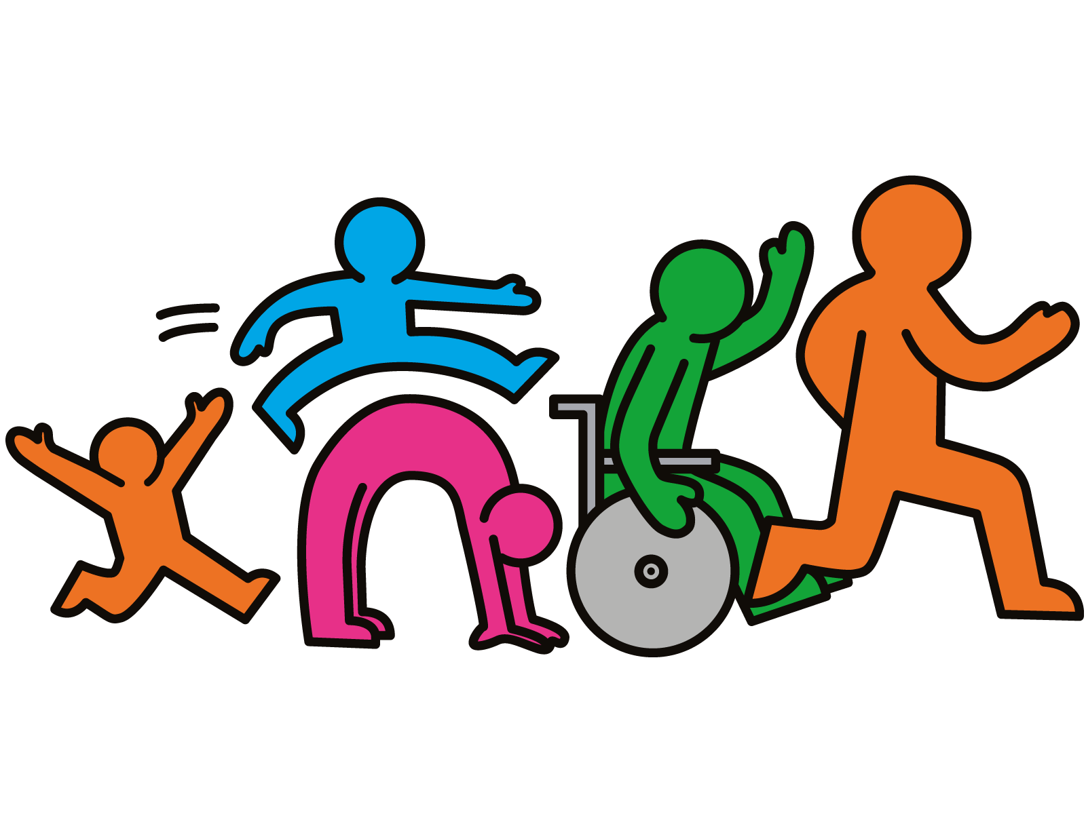

The NHS advises that children and young people aged 5 to 18 should aim for an average of at least 60 minutes of moderate intensity physical activity a day across the week.

Physical activity is also proven to make us feel happier, so get your family involved too!